Capstone Project
Formula 1 Tire Degradation Modeling & Race Strategy Simulation
Final Report

- Define the Problem Statement: Provide a well-defined problem statement that clearly articulates the goals, challenges, and potential benefits of your machine learning solution.

The goal of the project was to answer the question: “As an F1 Team Principal, should we pit now or stay out?”. As was evidenced in the 2025 Qatar Grand Prix, pitting at the wrong time can be the difference between winning and losing a race, and given the closeness of the 2025 season top 3 finishers (points standings), winning or losing a single race proved to be difference in winning or losing the season. The challenge is to formulate a pit strategy (use of tire compounds and stint lengths) that adheres to F1 rules and is adaptive to race day conditions (i.e. when a safety car situation occurs, do we pit then, or stay out?). The main benefit of the solution developed is that it provides (outputs) optimal race day pit strategies, as well as allowing the race engineer to enter a safety car event into the simulator and outputs new optimal pit strategies, ultimately answering the question, “pit now, or stay out?”.

- Model Outcomes or Predictions: Identify the type of learning (classification or regression) and specify the expected output of your selected model. Determine whether supervised or unsupervised learning algorithms will be used.

Supervised regression models were built that predict F1 circuit (venue) race car lap times based on a fuel-load model (linear regression) and tire degradation model (2nd degree polynomial) which forms the basis of a race simulator. A pit strategy optimizer uses the race simulator to evaluate and recommend the top three pre-race and race day pit strategies.

- Data Acquisition: The deliverable at this step is to identify what data you plan to acquire and use with your model. For the best results, data should come from multiple sources and your analysis for including specific data should be clear. Please provide a clear visualization to assess the data’s potential to solve the problem as well.

The models used publicly available Formula 1 timing and telemetry data from Formula1.com, and FastF1 API. Combined these sources provided access to historical races by year, venue and driver. The FastF1 API is well documented as is the de facto source for historical F1 timing data.

The FastF1 API data source had all the necessary timing data to enable development of the lap time models. Thirty-one columns of information are available per lap. The project models used the columns indicated in green below in Table 3-1.

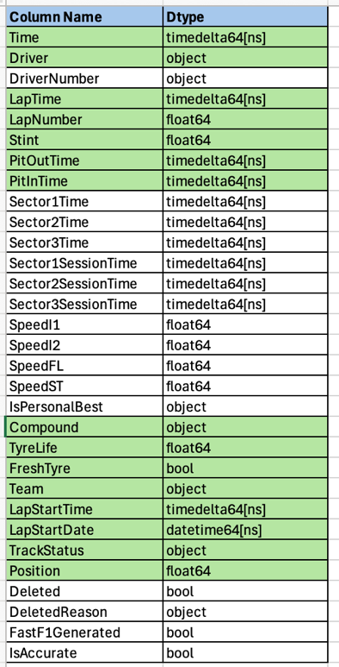

Table 3.1 – Per Lap Timing Data

- Data Preprocessing/Preparation: For this deliverable, you are tasked with detailing how you cleaned the data for your notebook.
- What techniques did you use to ensure your data was free of missing values, and inconsistencies?
- How did you split the data into training and test sets?
- Please include any necessary analysis and encoding steps you took as well.

As indicated by Table 3.1, all available timing data needed for model development was available via the FastF1 API – there were no missing values and inconsistencies, and there was no need to build proxies for missing data.

The training data consisted of three Qatar races (2021, 2023, 2024) for the top 10 finishers with Max Verstappen’s lap information held out. The test set was Max Verstappen’s lap information for Qatar 2025.

Most of the analysis focused on filtering out outlier data due to slow laps (pitting, yellow conditions, etc.). Below are two plots that indicate the necessary reviews and filtering.

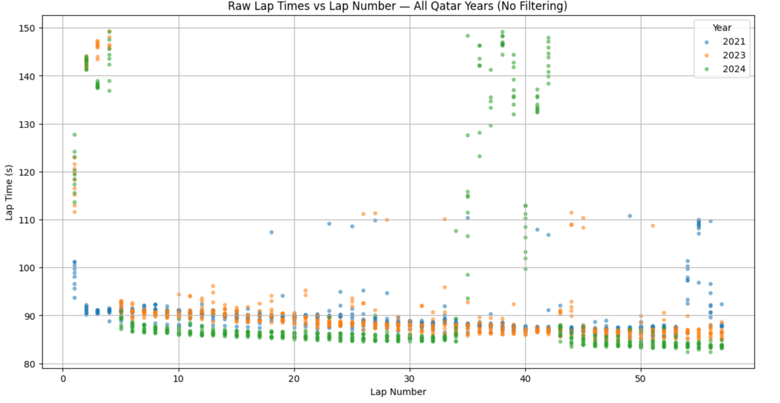
Figure 4-1 Test Data Prior to Slow Lap Filtering

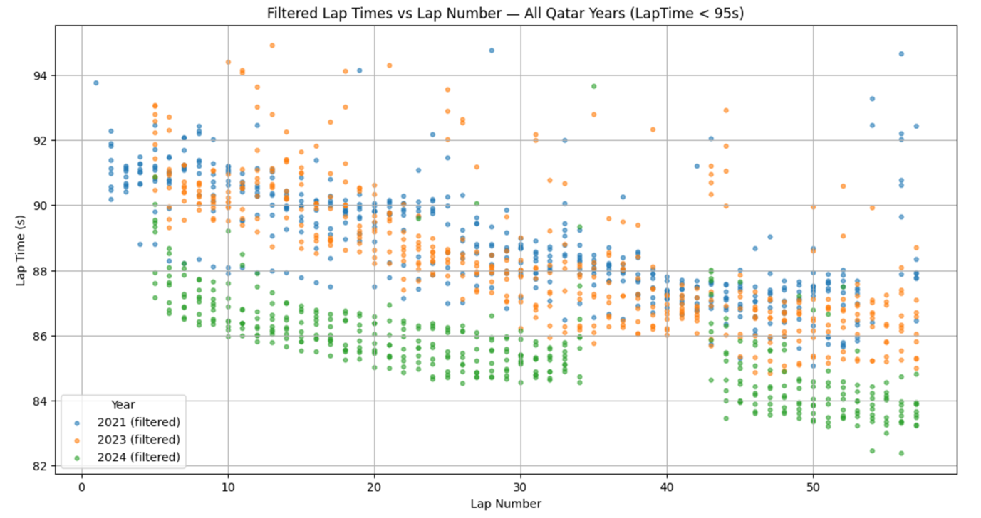
Figure 4-2 Test Data Post Slow Lap Filtering

- Modeling: For this deliverable, please document your selection of machine learning algorithms that you selected for your problem statement from the first deliverable.

The project utilized two models, a linear regression model for predicting fuel-load lap time reduction. Here’s the code for this:

# Prepare regression
X = df_y[["LapNumber"]]
y = df_y["lap_time_s"]
model = LinearRegression()
model.fit(X, y)
# Predictions
y_pred = model.predict(X)
# Metrics
slope = model.coef_[0]
rmse = np.sqrt(mean_squared_error(y, y_pred))
r2 = r2_score(y, y_pred)

Here’s the model used for the 2nd degree polynomial for tire degradation modeling for each tire compound:

df_c = df_deg[df_deg["Compound"] == comp]
X = df_c[[x_col]].values
y = df_c["lap_time_tire_only"].values
# Polynomial features (degree 2)
poly = PolynomialFeatures(degree=2)
X_poly = poly.fit_transform(X)
# Fit model
model = LinearRegression()
model.fit(X_poly, y)
# Predictions for metrics
y_pred_fit = model.predict(X_poly)
# Compute MAE and RMSE
mae = mean_absolute_error(y, y_pred_fit)
rmse = np.sqrt(mean_squared_error(y, y_pred_fit))
metrics.append((comp, mae, rmse))

- Model Evaluation: Share your model evaluation here. What types of models did you consider for your problem (classification, regression, unsupervised)? Articulate the evaluation metrics you used and how you determined which model was most optimal for your problem.

Supervised regression models (Linear Regression for fuel load modeling, and Polynomial Degree 2 used for tire degradation modeling.

Here’s the evaluation metrics for the fuel load model, which was done for each of the three years of the test data. The Linear Regression model is well documented in the F1 community as the best model for modeling fuel burn with laps getting faster per lap as the car gets lighter due to a reduced fuel mass.

Year 2023:
Slope = -0.101416 sec/lap
RMSE = 1.369405 sec
R² = 0.564886

For the tire degradation, four models were evaluated with the following results,
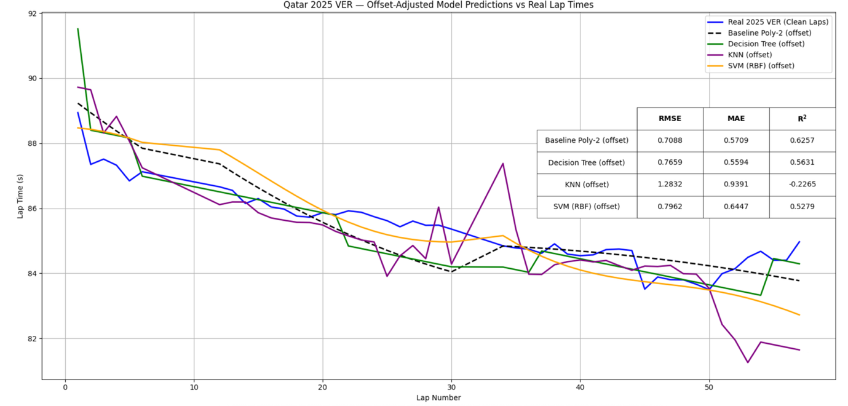

Figure 6-1 Model Comparison

As can be seen in the figure above, Polynomial-2, Decision Tree, KNN, and SVM (RBF) were used to predict lap times for the test data, Max Verstappen’s 2025 Qatar results, shown by the blue line. The KNN and Decision Tree models produced jagged results and not indicative of real-tire degradation. The SVM model produced smother curves, but because RMSE (0.7088), MAE (0.5709) were lower and R2 (0.6257) was higher, the Poly-2 model was chosen.

